PIZZA SALES QUERIES

1. 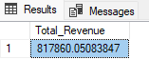select sum(total_price) as Total_Revenue from pizza_sales

select sum(total_price)/count(distinct order_id) as AVG_ORDER_VALUE

from pizza_sales

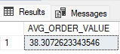

select sum(quantity) as Total_Pizza_Sold

from pizza_sales

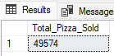

select count(distinct order_id) as Total_Orders

from pizza_sales

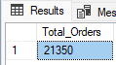

select sum(quantity)/count(distinct order_id) as AVG_Pizza_per_Order

from pizza_sales

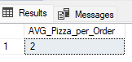

AVERAGE PIZZA PER ORDER IN TWO DECIMAL PLACES

select cast(cast(sum(quantity) as decimal(10,2))/

cast(count(distinct order_id) as decimal(10,2))

as decimal(10,2))

as AVG_Pizza_per_Order

from pizza_sales

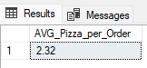

TOTAL REVENUE BY DAY OF WEEK

select DATENAME(dw, order_date) as Order_day, count(distinct order_id) as total_orders

from pizza_sales

Group by DATENAME(dw, order_date)

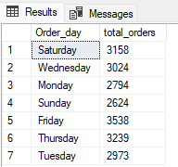

TOTAL REVENUE BY DATE

select DATENAME(MM, order_date) as Order_month, count(distinct order_id) as total_orders

from pizza_sales

Group by DATENAME(MM, order_date)

order by total_orders desc

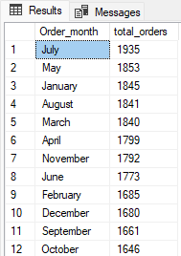

PERCENTAGE OF TOTAL REVENUE BY PIZZA CATEGORY

SELECT pizza_category, sum(total_price) as total_sales, sum(total_price)*100 /

(select sum(total_price) from pizza_sales) as pernt_total_sales

from pizza_sales

group by pizza_category

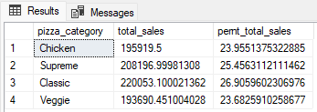

TOTAL REVENUE BY PIZZA SIZE IN FEBRUARY

select pizza_size, sum(total_price) as total_sales

from pizza_sales

where month(order_date) = 2

group by pizza_size

Order by total_sales desc

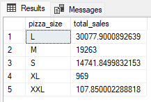

SELECT pizza_size, sum(total_price) as total_sales, sum(total_price)*100 /

(select sum(total_price) from pizza_sales) as pernt_total_sales

from pizza_sales

group by pizza_size

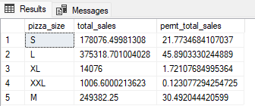

PIZZA SIZE BY TOTAL REVENUE & % REVENUE FOR JANUARY TO TWO DECIMAL PLACES

SELECT pizza_size, CAST(sum(total_price) as DECIMAL(10,2)) as total_sales , CAST(sum(total_price)*100 /

(select sum(total_price) from pizza_sales where month(order_date) =1) AS DECIMAL(10,2)) as pernt_total_sales

from pizza_sales

where month(order_date) =1

group by pizza_size

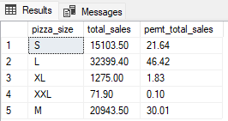

TOP 5 PIZZAS BY REVENUE

select TOP 5 pizza_name, sum(total_price) as TOTAL_REVENUE

from pizza_sales

group by pizza_name

ORDER BY TOTAL_REVENUE DESC

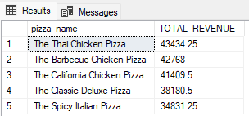

BOTTOM 5 PIZZAS BY REVENUE

select TOP 5 pizza_name, sum(total_price) as TOTAL_REVENUE

from pizza_sales

group by pizza_name

ORDER BY TOTAL_REVENUE

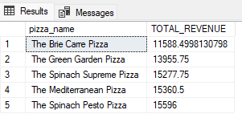

Top 5 pizzas by quantity

select TOP 5 pizza_name, sum(quantity) as Quantity

from pizza_sales

group by pizza_name

ORDER BY Quantity desc

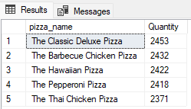

Bottom 5 pizzas by quantity

select TOP 5 pizza_name, sum(quantity) as Quantity

from pizza_sales

group by pizza_name

ORDER BY Quantity

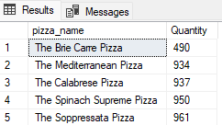

TOP 5 PIZZAS BY ORDERS

select TOP 5 pizza_name, count(distinct order_id) as Total_Orders

from pizza_sales

group by pizza_name

ORDER BY Total_Orders desc

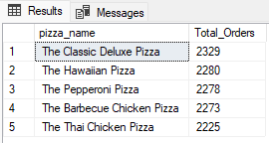

BOTTOM 5 PIZZAS BY ORDERS

select TOP 5 pizza_name, count(distinct order_id) as Total_Orders

from pizza_sales

group by pizza_name

ORDER BY Total_Orders

